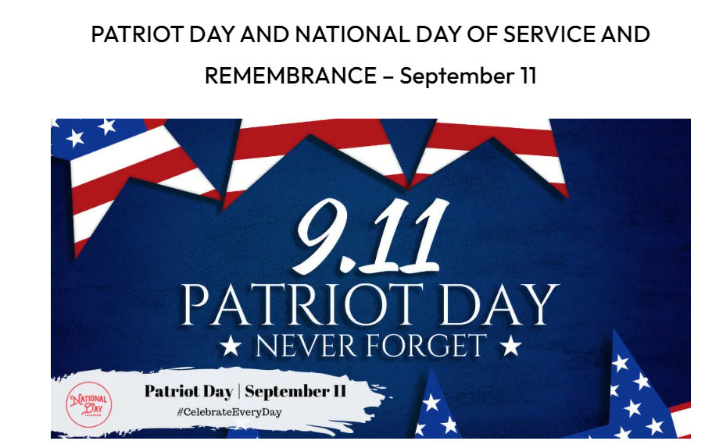

Let’s Celebrate

September 5th – National Be Late for Something Day

September 7th – National Salami Day

September 14th – National Cream-filled Donut Day

September 18th – National Rice Krispies Treats Day

September 20th – National String Cheese Day

September 21st – National World Gratitude Day

September 25th – National Family Day

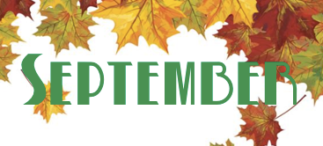

**“FYI”**

Tim Turner with Benton Fire Department will enjoy coffee and conversation on 9/7

Come talk with Dr. Dale McPhearson and see what are some things we can do to age – better.

Come visit the St Luke’s Outreach Ministries Bus on 9/19

Bring a picture of your Family on 9/25

Wear your favorite Team Jersey on 9/28



September 3rd – Beverly Jackson September 8th – Evelyn Johnson

September 12th – Martha Pearson September 13th – Victoria Hall

September 14th – Cheryl Davis September 16th – Linda Wicker