

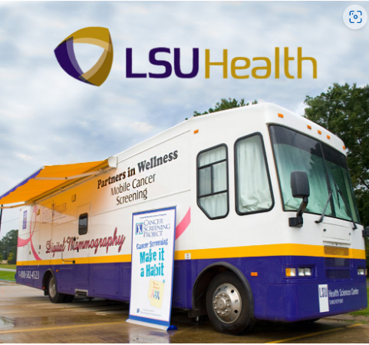

**Where:** Benton Counsel on Aging

202 Sibley Benton, La 71006

**When:** November 8, 2022

9:00 am – 12 noon

**Who:** Woman 40 years and over, who has not had a screening mammogram within a year. You can be scheduled through Bossier Council on Aging or the you can walk onto the mobile van to receive screening.

**What:** Complete the attached file by clicking (Ctrl+Click to follow link) on the hyperlink and calling Benton Council on Aging (318) 965-9981 or fax it to *Partners In Wellness LSUHSC-S (318) 675-0481.*

C:\Users\Debbie\Documents\Appt. Screening Sheet - Benton Council on Aging (2).doc